**Task 1:**

#include<iostream>

using namespace std;

int main(){

int arr[3][3];

cout<<"enter elements in 3*3 matrix "<<endl;

for(int i=0;i<3;i++){

for(int j=0;j<3;j++){

cin>>arr[i][j];

}

}

cout<<"the given matrix is "<<endl;

for(int i=0;i<3;i++){

for(int j=0;j<3;j++){

int x=arr[i][j];

cout<<x<<" ";

}cout<<endl;

}

cout<<"the sum of left and right diagonals of matrix is "<<" ";

int num1=arr[0][0];

int num3=arr[0][2];

int num4=arr[2][0];

int num2=arr[2][2];

cout<<num1+num2+num3+num4;

return 0;

}

**Output:**

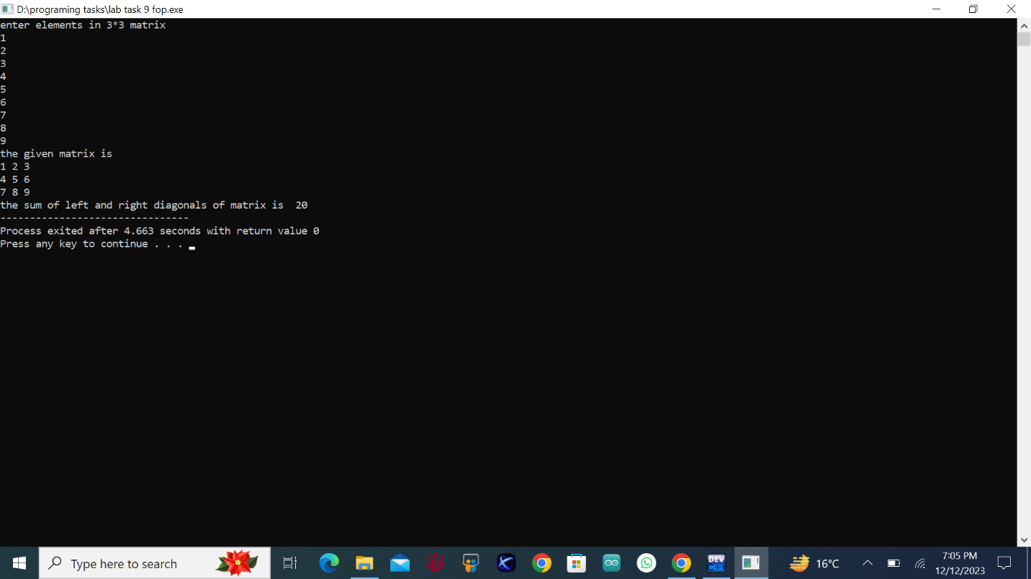

**Task 2:**

#include<iostream>

using namespace std;

void addition(int mat1[3][3],int mat2[3][3],int sum[3][3]){

int a,b;

for(int i=0;i<3;i++){

for(int j=0;j<3;j++){

sum[i][j]=mat1[i][j]+mat2[i][j];

}

}

}

int main(){

int arr1[3][3],arr2[3][3],result[3][3];

cout<<"enter the elements in the first matrix "<<endl;

for(int i=0;i<3;i++){

for(int j=0;j<3;j++){

cin>>arr1[i][j];

}

}

cout<<"the first entered matrix is "<<endl;

for(int i=0;i<3;i++){

for(int j=0;j<3;j++){

cout<<arr1[i][j]<<" ";

}

cout<<endl;

}

cout<<"enter the elements in the second matrix "<<endl;

for(int i=0;i<3;i++){

for(int j=0;j<3;j++){

cin>>arr2[i][j];

}

}

cout<<"the second entered matrix is "<<endl;

for(int i=0;i<3;i++){

for(int j=0;j<3;j++){

cout<<arr2[i][j]<<" ";

}

cout<<endl;

}

addition(arr1,arr2,result);

cout<<"the sum of the two enetred matrix is "<<endl;

for(int i=0;i<3;i++){

for(int j=0;j<3;j++){

cout<<result[i][j]<<" ";

}

cout<<endl;

}

return 0;

}

**Output:**

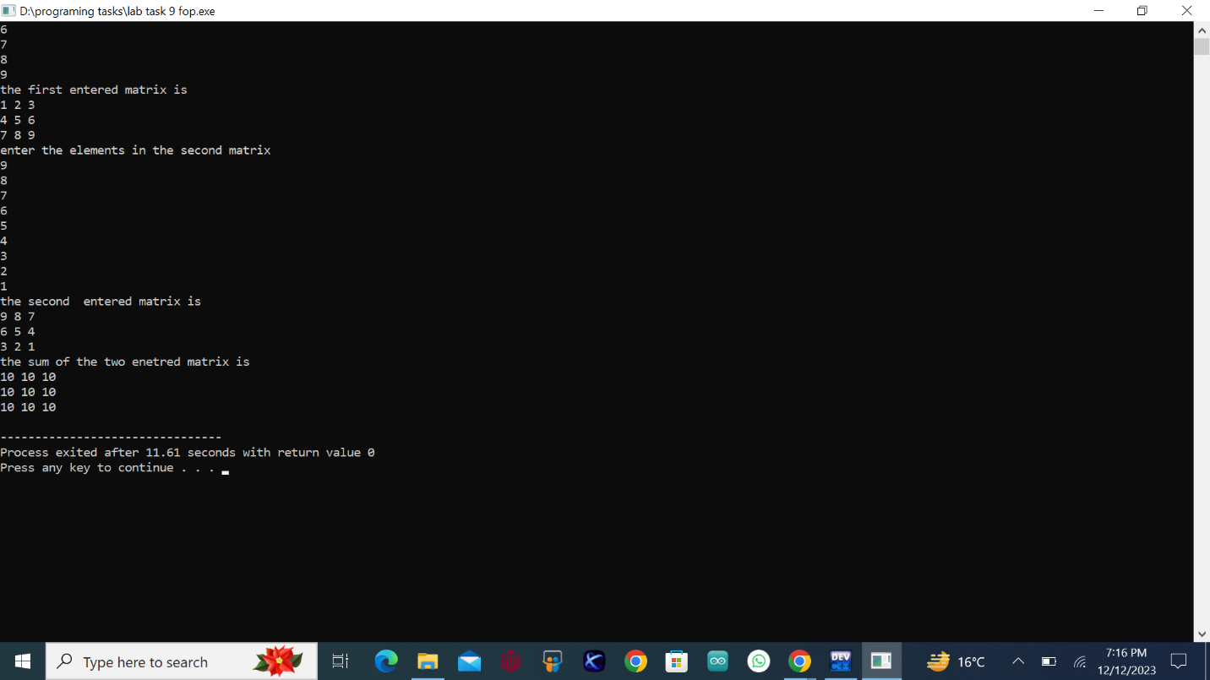

**Task 3:**

#include<iostream>

using namespace std;

void transpose(int arr[3][3],int result[3][3]){

for(int i=0;i<3;i++){

for(int j=0;j<3;j++){

result[j][i]=arr[i][j];

}

}

}

int main(){

int arr1[3][3],res[3][3];

cout<<"enter desired elements of 3*3 matrix to find its transpose"<<endl;

for(int i=0;i<3;i++){

for(int j=0;j<3;j++){

cin>>arr1[i][j];

}

}

cout<<"the tranpose of given matrix is "<<endl;

transpose(arr1,res);

for(int i=0;i<3;i++){

for(int j=0;j<3;j++){

cout<<res[i][j]<<" ";

}

cout<<endl;

}

return 0;

}

**Output:**

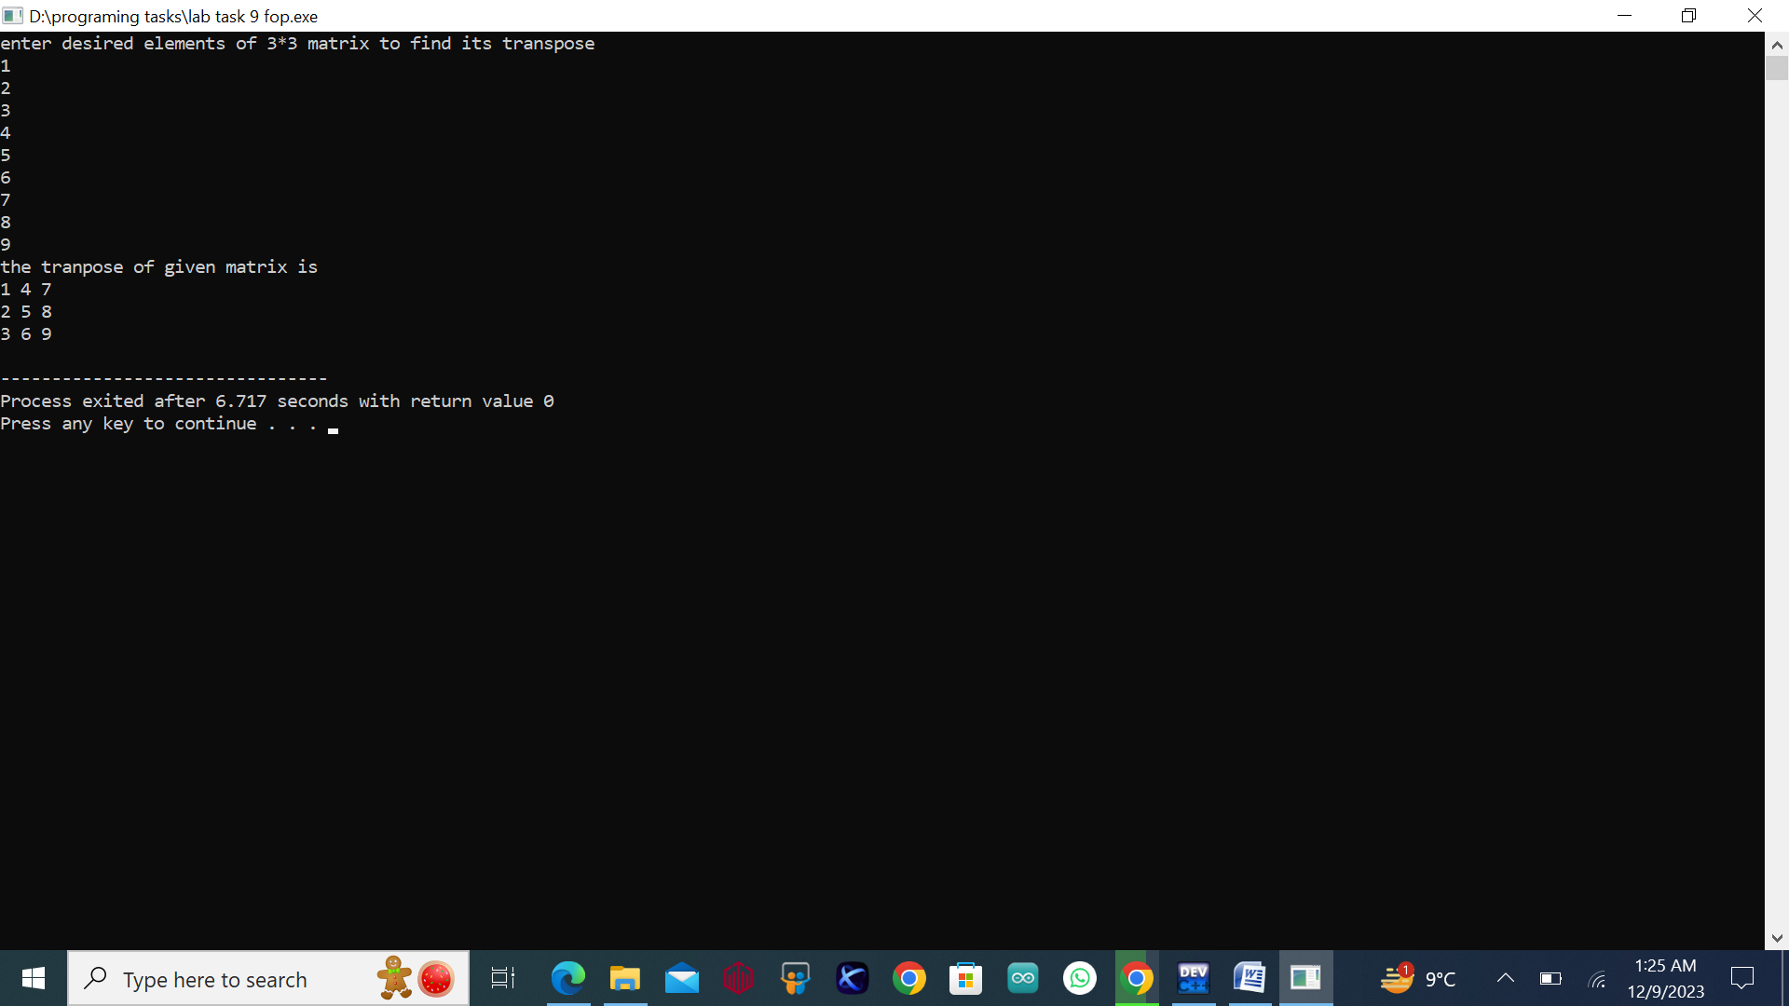

**Task 4:**

#include<iostream>

using namespace std;

void multiply(int arr1[3][3],int arr2[3][3],int result[3][3]){

for(int i=0;i<3;i++){

for(int j=0;j<3;j++){

int sum=0;

for(int k=0;k<3;k++){

sum+=arr1[i][k]*arr2[k][j];

}

result[i][j]=sum;

}

}

}

int main(){

int matrix1[3][3],matrix2[3][3],product[3][3];

cout<<"enter the elements in the first matrix "<<endl;

for(int i=0;i<3;i++){

for(int j=0;j<3;j++){

cin>>matrix1[i][j];

}

}

cout<<"enter the elements in the second matrix "<<endl;

for(int i=0;i<3;i++){

for(int j=0;j<3;j++){

cin>>matrix2[i][j];

}

}

cout<<"the enetered first and second matrix respectively are as follows "<<endl;

for(int i=0;i<3;i++){

for(int j=0;j<3;j++){

cout<<matrix1[i][j]<<" ";

}

cout<<endl;

}

cout<<endl;

for(int i=0;i<3;i++){

for(int j=0;j<3;j++){

cout<<matrix2[i][j]<<" ";

}

cout<<endl;

}

multiply(matrix1,matrix2,product);

cout<<"the product of the two matrix is as follows "<<endl;

for(int i=0;i<3;i++){

for(int j=0;j<3;j++){

cout<<product[i][j]<<" ";

}

cout<<endl;

}

return 0;

}

**Output:**

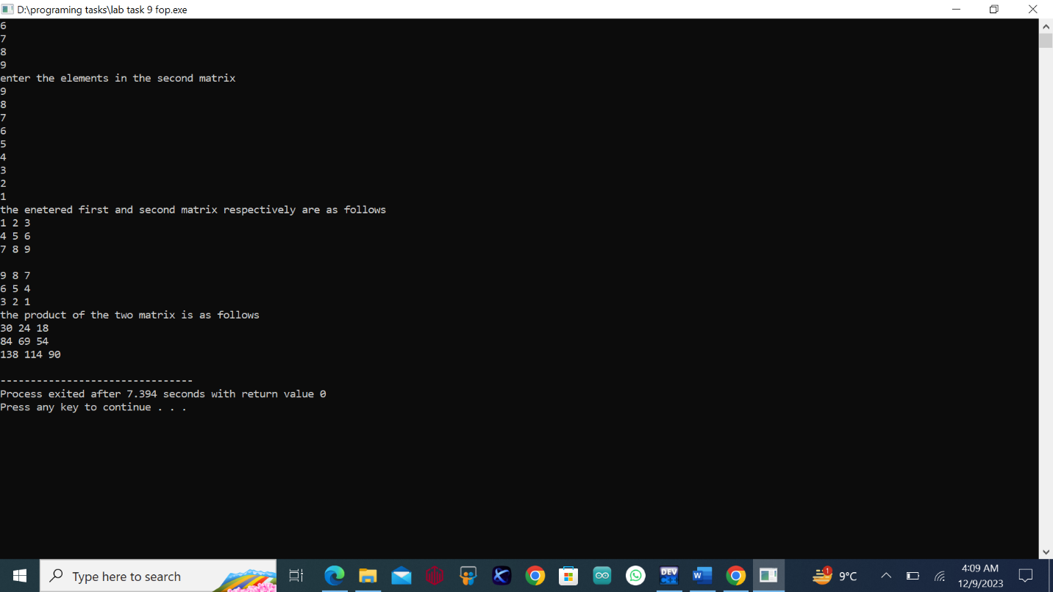

**Task 5:**

#include<iostream>

using namespace std;

void table(int num,int i){

if(i>10){

return ;

}

cout<<num<<"*"<<i<<" = "<<num*i<<endl;

return table(num, i+1);

}

int main(){

int number=15,i,result;

cout<<"the table of 15 is "<<endl;

table(number,i);

return 0;

}

**Output:**

**Home task:**

#include<iostream>

using namespace std;

int main(){

int mat1[3][3];

cout<<"enter the elements in the matrix"<<endl;

for(int i=0;i<3;i++){

for(int j=0;j<3;j++){

cin>>mat1[i][j];

}

}

cout<<"entered matrix is "<<endl;

for(int i=0;i<3;i++){

for(int j=0;j<3;j++){

cout<<mat1[i][j]<<" ";

}

cout<<endl;

}

cout<<"the determinant of the given matrix is "<<" ";

int det=0;

for(int i=0;i<3;i++){

det=det+mat1[0][i]*(mat1[1][(i+1)%3]*mat1[2][(i+2)%3]-mat1[1][(i+2)%3]*mat1[2][(i+1)%3]);

}

cout<<det<<endl;

cout<<endl;

cout<<endl;

if(det==0){

cout<<"the inverse is not possible because its determinant is zero "<<endl;

return 0;

}

cout<<"the adjoint is the matrix is "<<endl;

for(int i=0;i<3;i++){

for(int j=0;j<3;j++){

cout<<((mat1[(j+1)%3][(i+1)%3]*mat1[(j+2)%3][(i+2)%3])-(mat1[(j+1)%3][(i+2)%3]*mat1[(j+2)%3][(i+1)%3]))<<" ";

}

cout<<endl;

}

cout<<"the inverse of the given matrix is follows "<<endl;

cout<<"inverse = adjoint/determinant"<<endl;

for(int i=0;i<3;i++){

for(int j=0;j<3;j++){

cout<<((mat1[(j+1)%3][(i+1)%3]*mat1[(j+2)%3][(i+2)%3])-(mat1[(j+1)%3][(i+2)%3]*mat1[(j+2)%3][(i+1)%3])/det)<<" ";

}

cout<<endl;

}

return 0;

}

**Output:**

